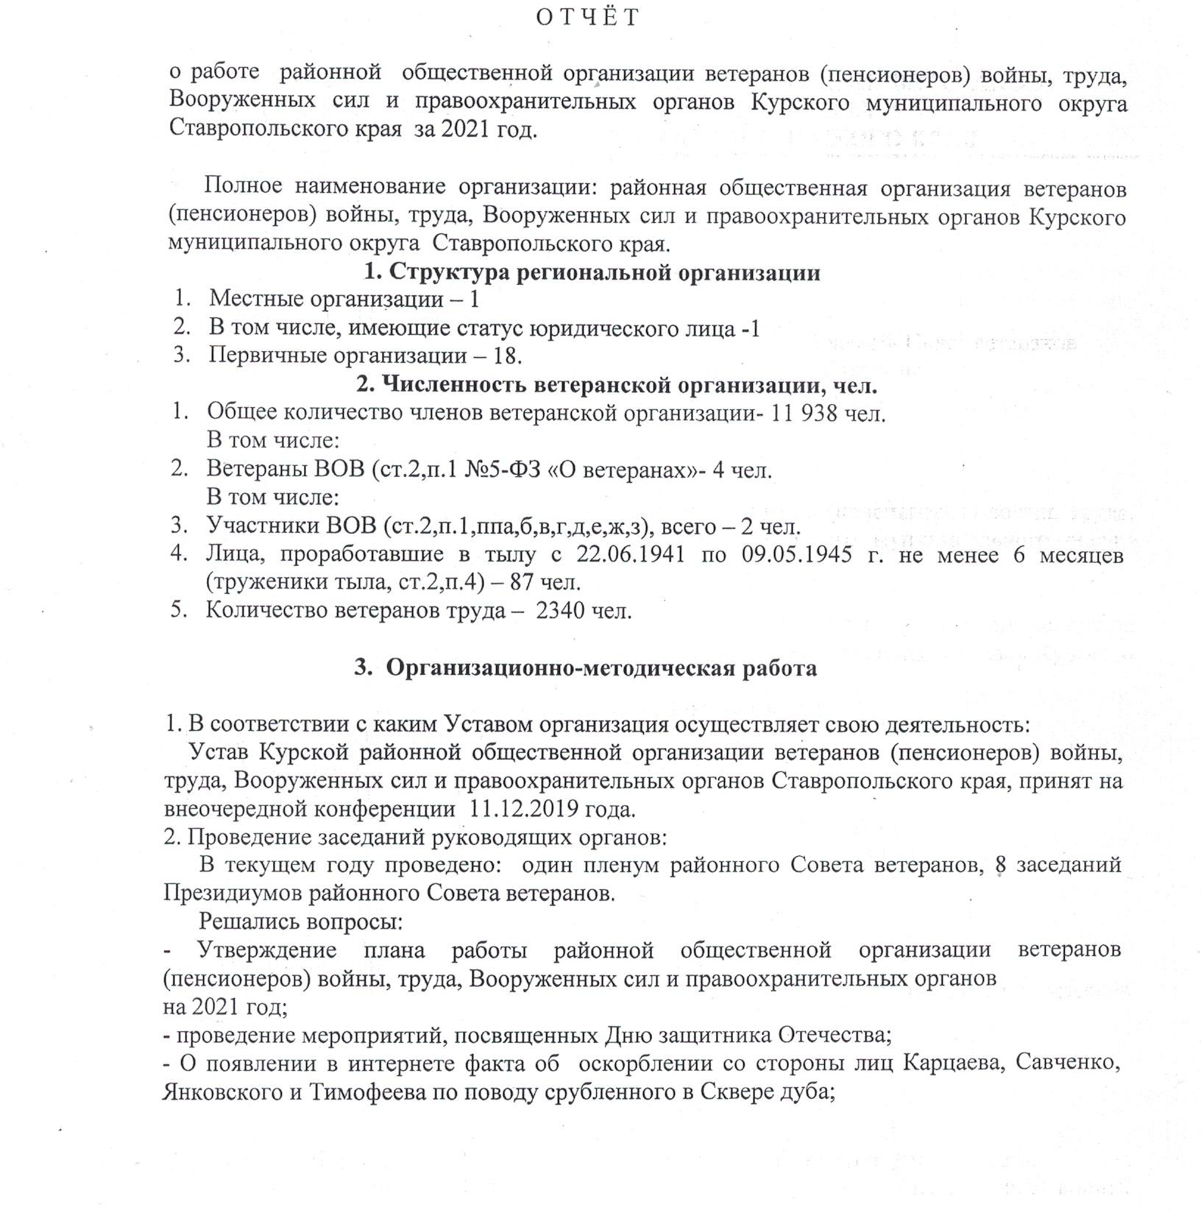

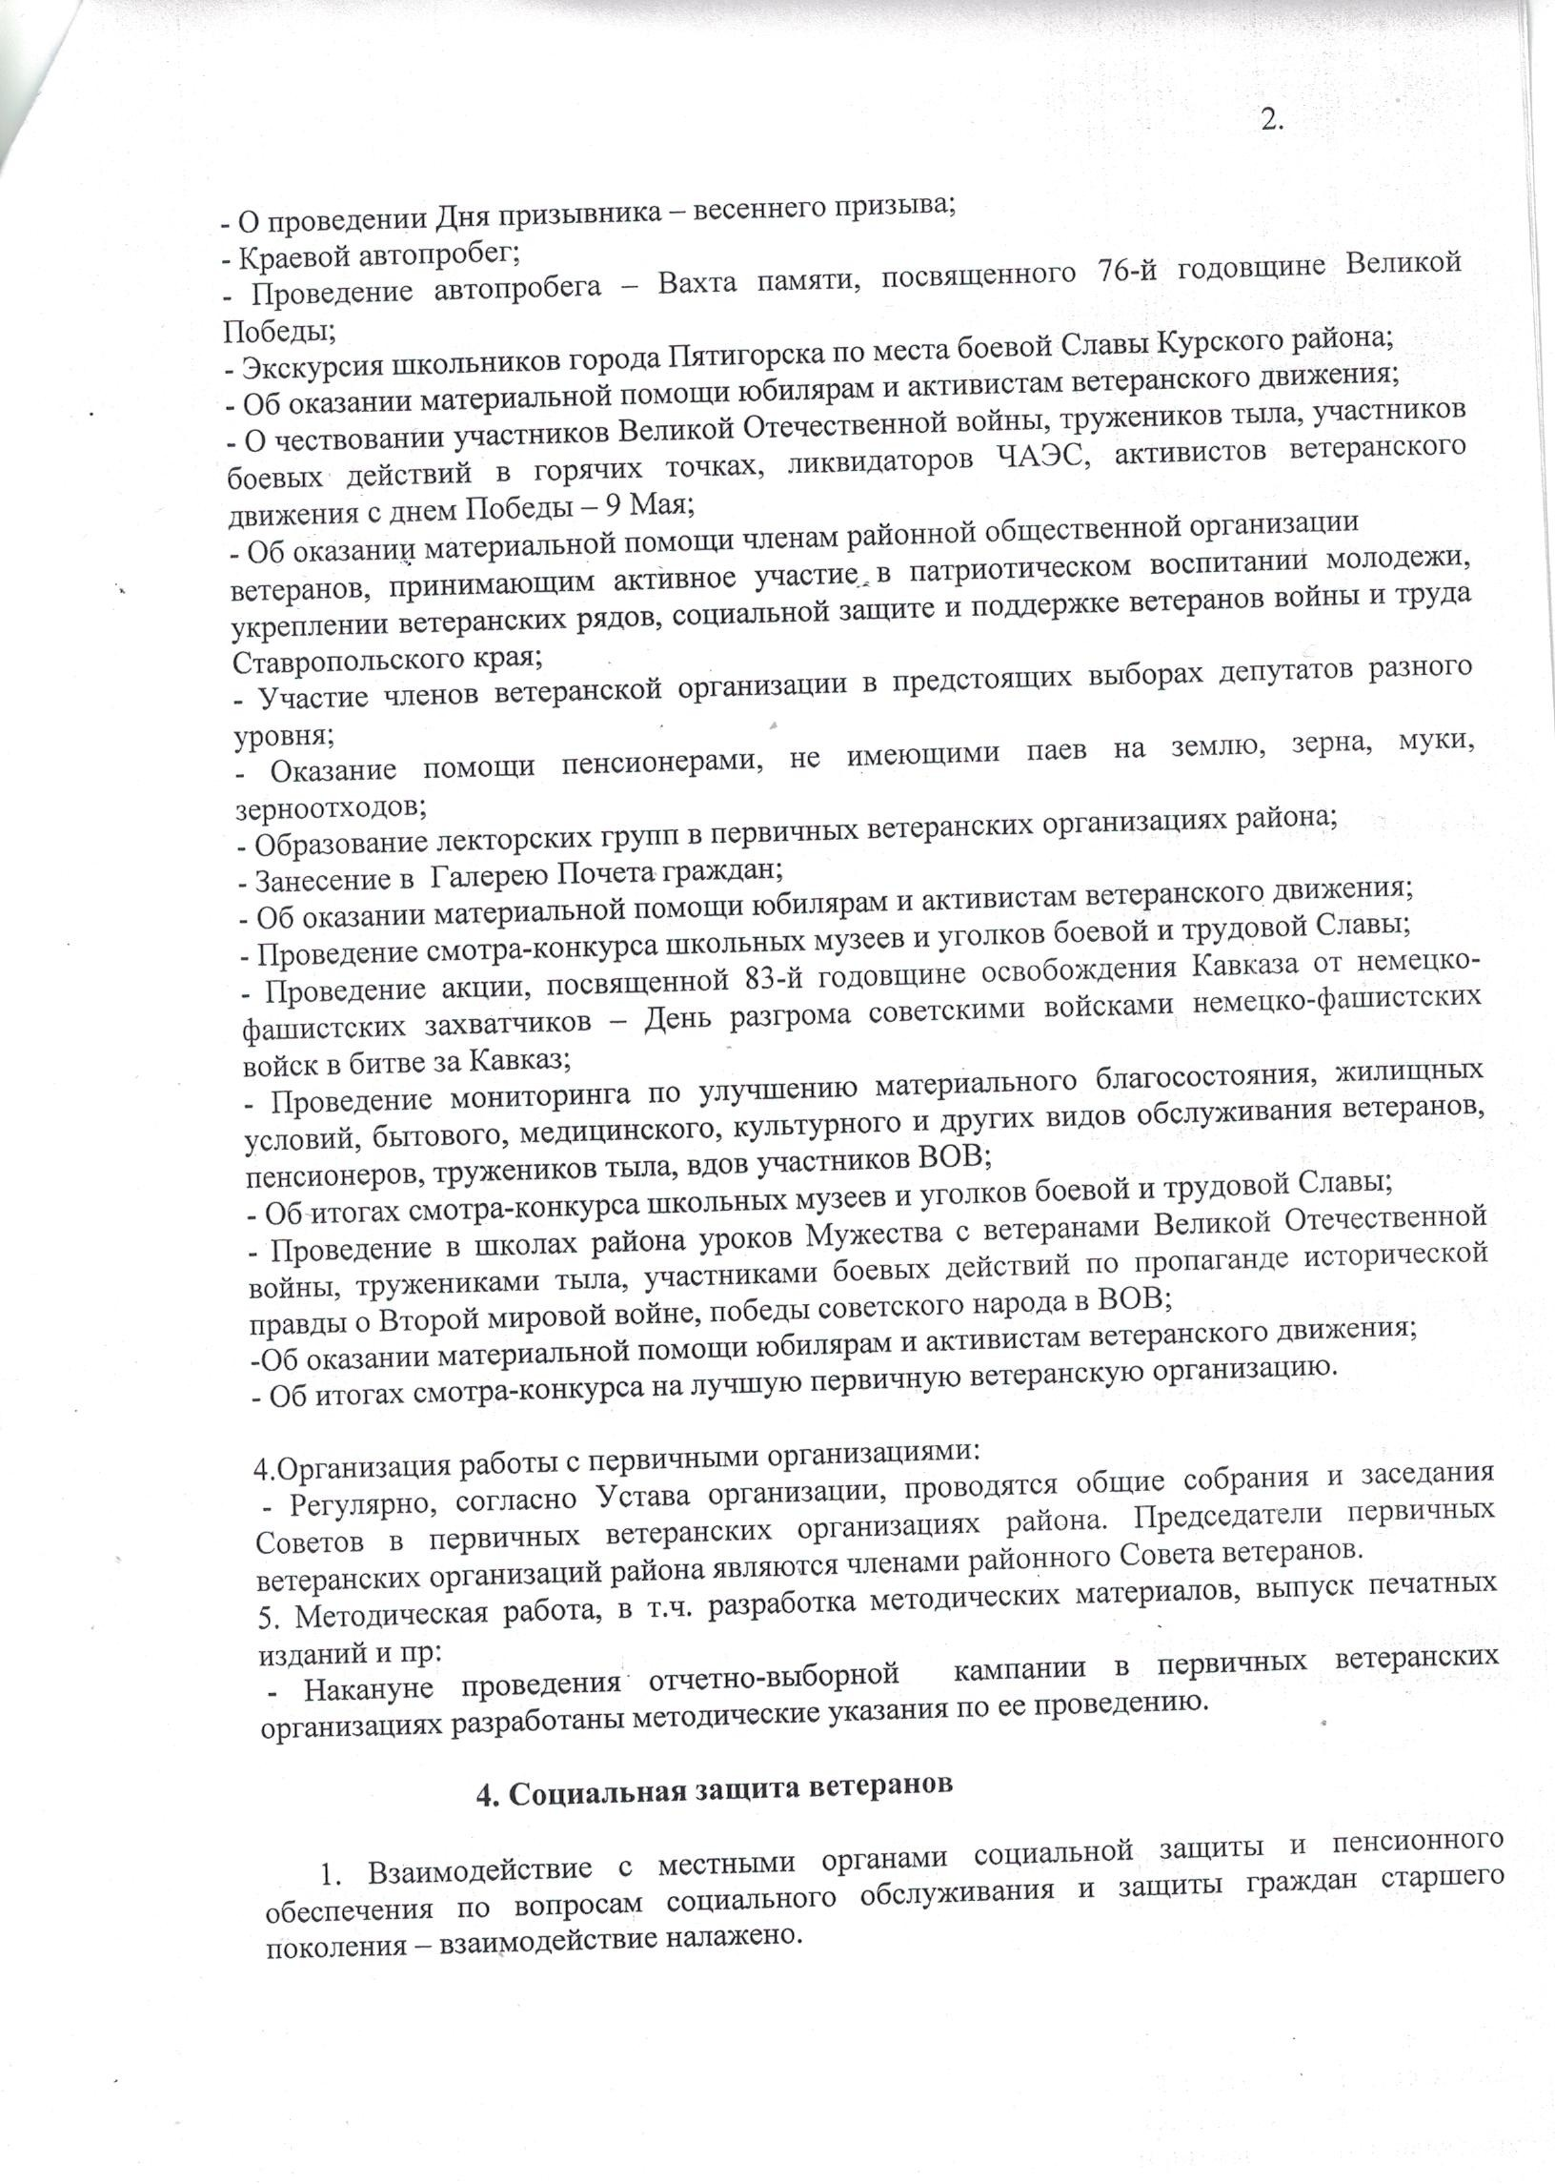
_ _By_)3 qpr_yeKno_pe_Bn_3coBTynscppoae_oonop6anneeJTw_HeHo6 Bpva6HTpp6opn BpcpooHBMao HeMae0oBMenoeKocoouB_gbpHccKB_TrTKeea3ToBBTebT_taTeoa3eyotTyHMa3xuvHe_e HoHc9c_BJTBaou etoToeerKc_ateaHH_uHepep_aM6K_HeHBpyy_HHxyoo nb Bx HBTM_B_yc B_Bexp_TceMeooeeete_tMme

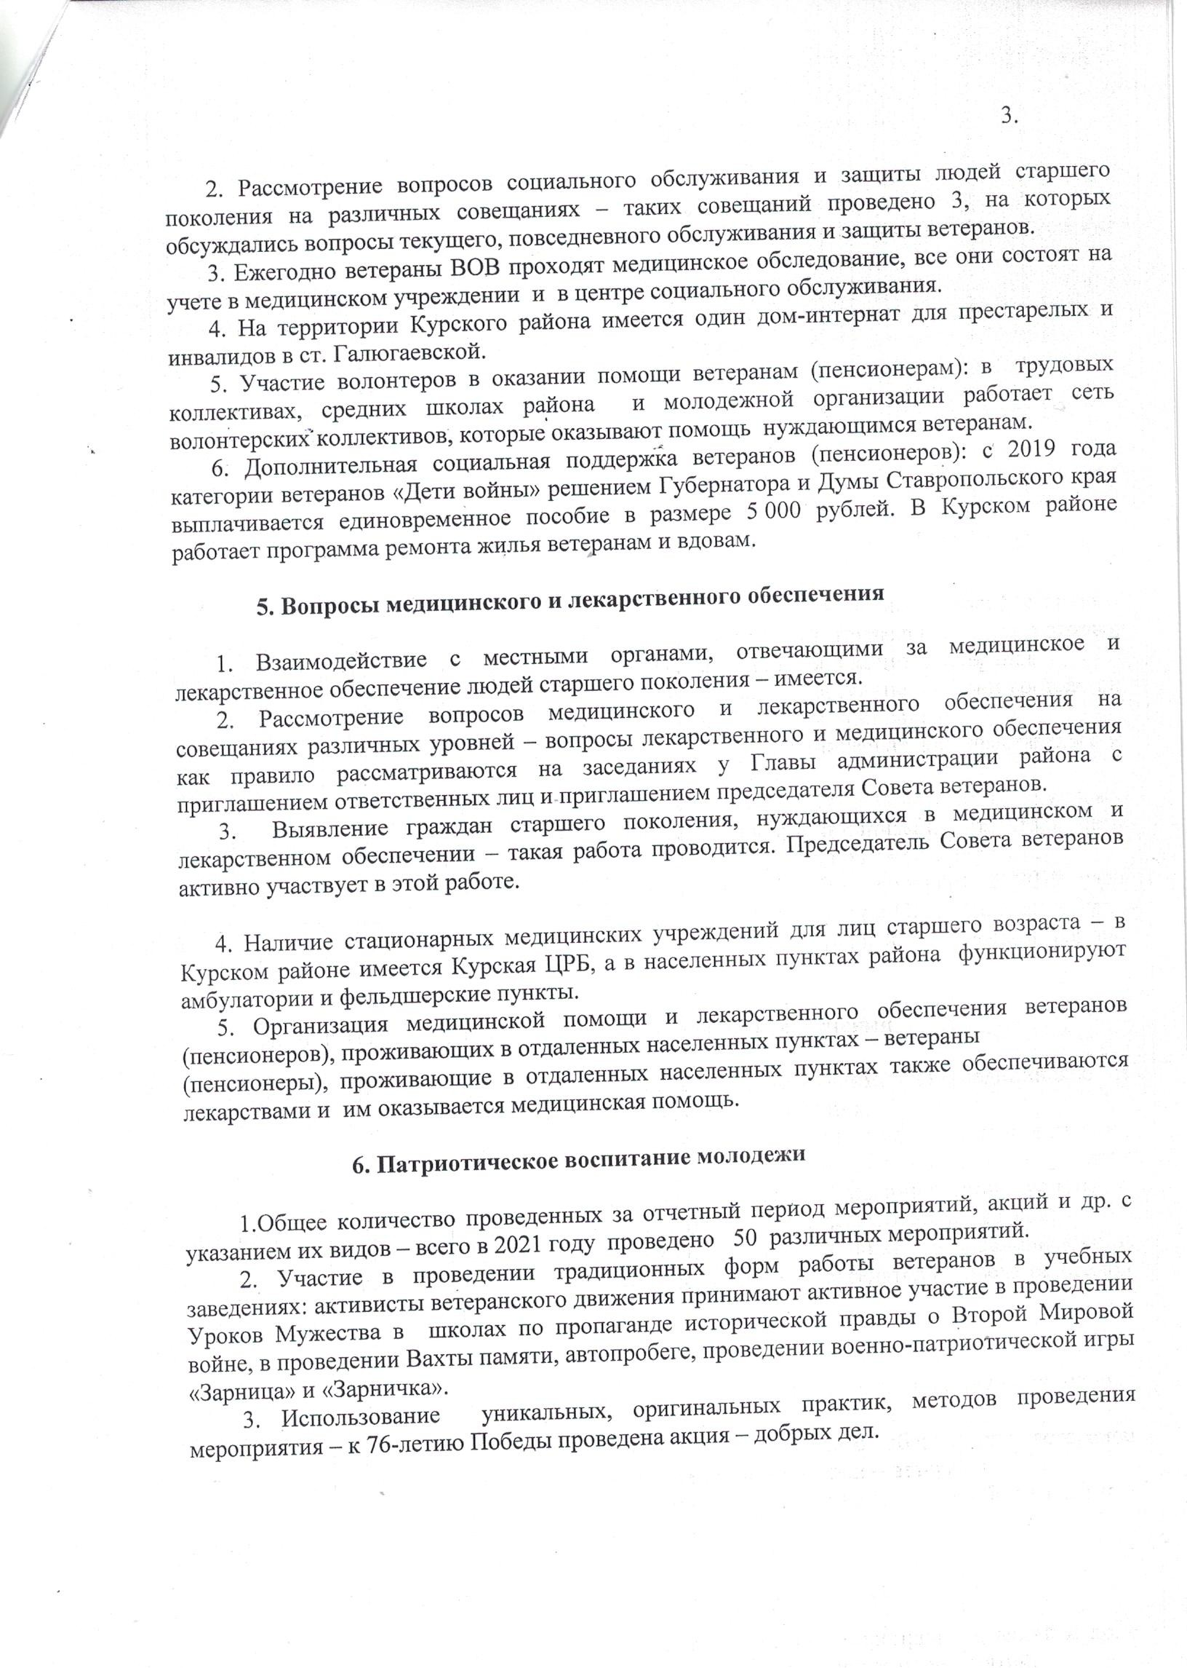
KBKBcKnJr[_oJEc_oab((Jl_yoapennJn_Jn_TleyxnBKKMeeeJn_oKpea3JT6aHrr HeH25aJu_cpoaJrE KccpTa_K_n_cpawnTaHeclopuT_w_wHoTpot _om BasoBpMBoHB_Hce BeelapaKnaa6_eeHmH_p Be Brmxc_ppxow yaTeac_xoob_MJn_McTevHoomep_TnB_Hx_m
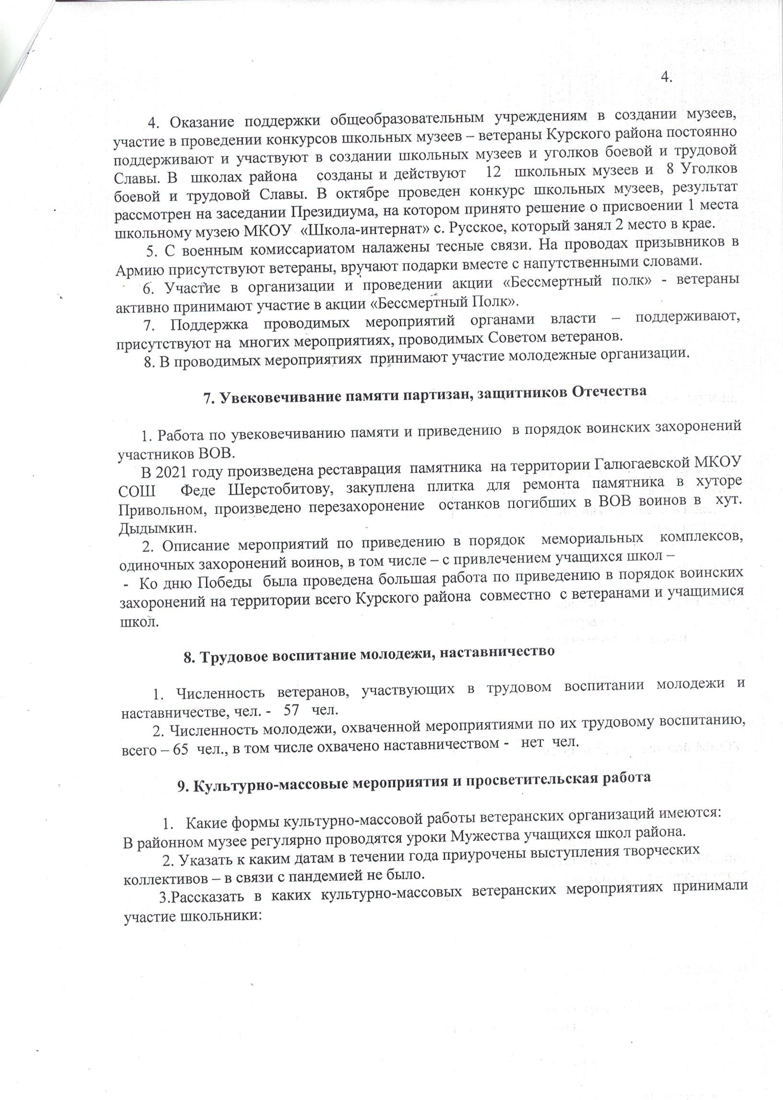
annoK_pupTyMwM_cB6HBByotoHoT2_Jn_oculyoHTbH2n_bBH9J0lpJrx_a_o Mcrm_aTTHo3_TT7,x_yauyofMxJn_enHym5yeobpae_npJyBBo_9c_poM_ebooHTMpTo3Hp_e BpHyoomH3e6r4Bor BbA_aba _e_leeLn_H_mvc_xAKHT ae Byo_m3Hco Bnaenecawban4ppoBTHH_peoo BypoaK_e_n Bbp Beceep_H3T,4e_ywnaoaB_e_xmB_
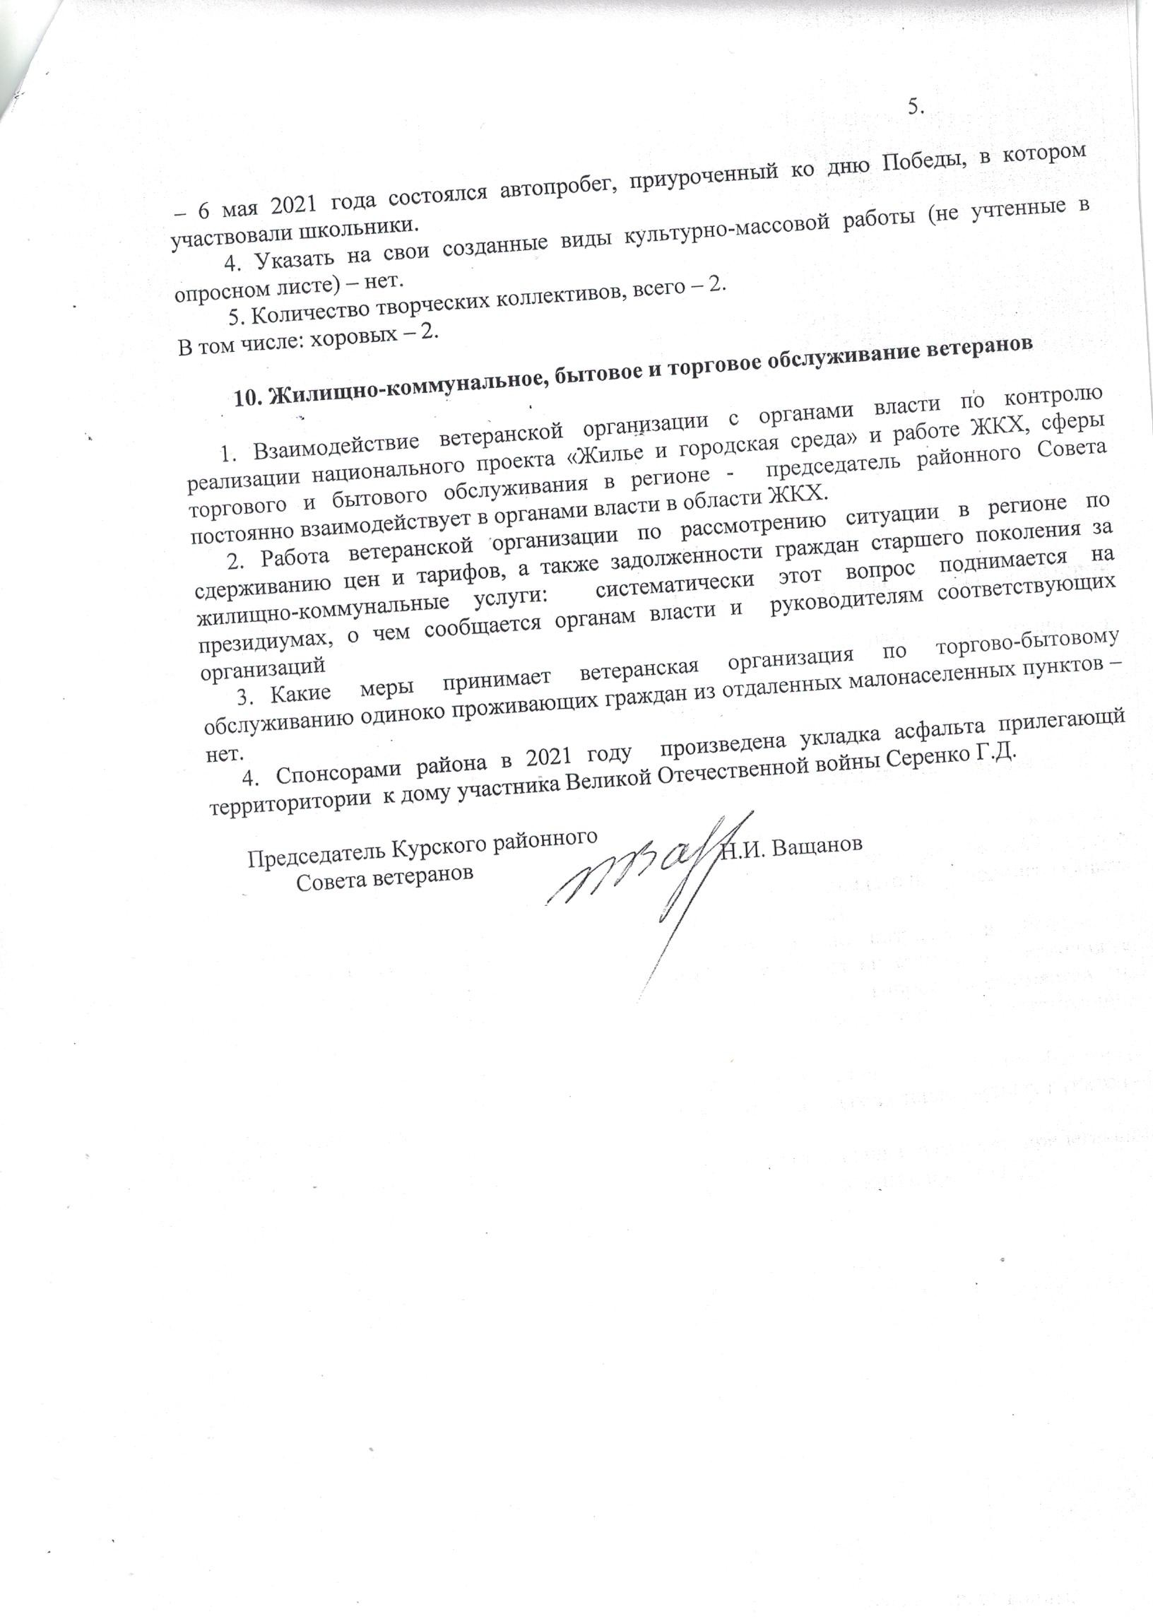
_ pTncxneoooo_HaJn_Tppp_c6eee_reTTJn_p2cTp_ot3al_1o_3Jn_x p_4H3Bo_nJu_ytycBayto_ycttHpxupTr_BH33H_a _oo_ce_a_aoo6ap_4_HycB_nKcocKy_ Bya_hf_oaT_eoH3TH_oJE0vxyoay_emoy$aA9ca6pueJ0hfoeTM4bTJy_goylpmue_aeyoTeycooaalM_Jn_cHToAH gTbeaJTeBKeeBycep_JeT_p ycTovmyt6ybAaerc_ybeHoHoppoTTH

